

Europass  Curriculum Vitae |  | 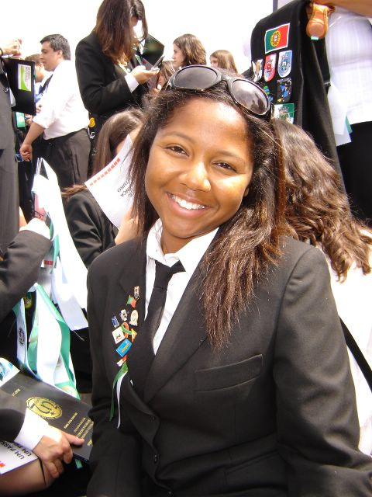
Personal information
Surname(s) / First name(s) |  | Surname(s): Ribeiro Baldé First name(s): Lurdes
Address(es) |  | Quinta da Piedade, Praceta Arquimedes Santos n.º2 4 B; 2625-163 Povoa de Santa Iria
Telephone(s) |  | +351 21 9564619 |  |  |  |  | Mobile: |  |  |  | +351 91 6493822
E-mail |  | Baldocas@gmail.com or LurdesTEC@hotmail.com
Identity Card number |  | 12236699
Nationality |  | Portuguese
Date of birth |  | 28th October 1983
Gender |  | Female
Desired employment / Occupational field |  | PGCE secondary in science (5th year of the Natural Sciences teaching course in FCTUNL - equivalent)
Work experience |  | - Store assistant in August 2000;  - Hip hop teaching to children in 2001 and 2002;  - Staff and volunteer in adventure camps for children in August 2002, 2003, and 2005;  - Since 2004, study supporter in several subjects (History, Math, English, Portuguese, science and chemistry)to children ages 10-14;  - sSaff in international adventures park (in my scouts group) in August 2005;  - Volunteer (baby institutions and fight against hunger society) in April until June 2005;  - Workshops with cork and lead materials in August 2005.
Education and training
Title of qualification awarded |  | - GCSE Certified (equivalent) in July 2001-2002 ;  - Post-graduate study (4th year of studies in the Natural Sciences Teaching course) in July 2006;
Principal subjects/occupational skills covered |  | Biology, Zoology, Chemistry, Math, Physics, Botany, Genetics, Microbiology, Didactics, ICT In Education, Educational Sociology, School Policy and Management Education and Development
Name and type of organization providing education and training |  | Gil Vicente High School  New University of Lisbon, Faculty of Sciences and Technology
Level in national or international classification |  | Secondary level with an overall outcome of 14 out of 20  Post-Graduate level with an overall outcome of 13 out of 20
Personal skills and competences
Mother tongue(s) |  | Portuguese
Other language(s) |  | English and Spanish
Self-assessment |  |  | Understanding |  |  |  |  | Speaking |  |  |  |  | Writing
European level (*) |  |  | Listening |  | Reading |  |  | Spoken interaction |  | Spoken production
Language |  |  | Spanish | A2 |  | A1 |  |  | A2 |  |  | A1 |  | A1
Language |  |  | English | B2 |  | B2 |  |  | B2 |  |  | B1 |  | B1
 |  | (*) Common European Framework of Reference for Languages
Social skills and competences |  | good team spirit;  good adapting to multicultural environments;  good communication skills.
Organizational skills and competences |  | - Scouts pedagogical Initiation course on 31st May 2006;  - Planned several workshops about Environment, manual works and other activities on a regular basis since 2000;  - Good organization skills.
Computer skills and competences |  | - 2006 Educational Technology with a an overall outcome of 15 out of 20 (4th year in Natural Sciences Teaching course);  - 2001 Introduction to computers and programming with an overall outcome of 11 out of 20 (1st year in Natural Sciences Teaching course);  - 6th February 1997 master windows course at Tecliform Institute, with an overall outcome of 50 out of 100;  - Upper hand with some software instruments as microsoft Word, microsoft excel, movie maker, photoshop, canvas, paint net, Cmap and frontpage express.
Artistic skills and competences |  | - workshops with materials as cork and lead;  - hip hop teaching to children  - Rhythmic gymnastic, hip hop teaching to children, aerobic and step.
Other skills and competences |  | - teaching basis about camping;  - Practice in didactics camp games;  - scouts co-education
Driving license |  | - 22 nd August 2002  - B category vehicles
Additional information |  | - I have some hobbies like reading, going to the movies, going out with friends, cinema, music, theatre, slide and rappel, caves exploring, among others.  - I am a scout since 1993, and now I’m leading a group of 30 children ages 11-14.  I promote environmental activities, plan manual workshops with natural resources all over the year, camp with children and work as staff in international adventures parks.

