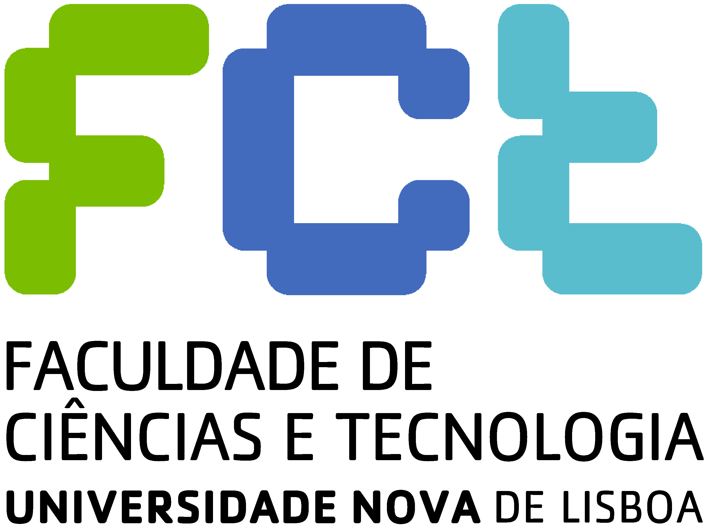


Program (provisional)
Project “Technology Assessment of Autonomous Robotics” (DAAD/CRUP) Conference
Universidade Nova de Lisboa/KIT-University of Karlsruhe

"Autonomous systems: inter-relations of technical and societal issues"
Monte de Caparica,
Campus FCT-UNL, November 5 and 6, 2009

November 5

- 9h-10h reception
- 10h-12h Opening session

Dean of FCT-UNL, Prof. Fernando Santana

Michael Decker, Professor of KIT-University of Karlsruhe

- J.Norberto Pires, Robotics in Portugal. A few examples of industry-academia cooperation, Professor at Universidade de Coimbra, Faculty of Sciences and Technology, founder of SPR-Portuguese Robotics Society
- José Barata: to be defined, Universidade Nova de Lisboa, Faculty of Sciences and Technology, CTS
- António Moniz: Anthropocentric robotics: assessment of organisational options, Universidade Nova de Lisboa, Faculty of Sciences and Technology, IET
- debate
- 12h-14h lunch
- 14h-18h Visit to Introsys (Parque Industrial da Moita)
- 20h- dinner

November 6
- 09h-13h working sessions (4 presentations)

- Christian Bauer, Ralf Mikut, Georg Bretthauer: Movement Generation and Safety Strategies for Humanoid Robots - Acceptance Issues from an Engineers Point of View, Institute for Applied Computer Science, Karlsruhe Institute of Technology (KIT)
- Luis Ribeiro, José Barata, Pedro Barreira: Is Ambient Intelligence a truly Human Centric Paradigm in Industry? Current Research and Application Scenario, Universidade Nova de Lisboa, Faculdade de Ciências e Tecnologia
- debate
- 11h – coffee/tea break

- U. Gengenbach, G. Bretthauer: A mechatronic system to restore accommodation, Karlsruhe Institute of Technology (KIT) Institut fuer Angewandte Informatik
- Diego Compagna, Stefan Derpmann, Kathrin Mauz : The operation of autonomous mobile-robot-assistants in the maintenance area adopting the "scenario-based design" approach, Universität Duisburg-Essen, Institut für Soziologie
- debate
- 13h-14h lunch
- 14h-17h continuation of working sessions (3 presentations)

- Tareq Syed: „Mechanical animals“ – the foundation of biomechanics, and its possible impact on a renewed understanding of mobile robots, Institute of Philosophy, University of Karlsruhe
- Mathias Gutmann: Some fundamentals of robo-ethics: How autonomous are autonomous systems?, Institute of Philosophy, University of Karlsruhe and ITAS-FZK
- Michael Decker: Technoid, humanoid, android? What should service robots look like?, Institute of Philosophy, University of Karlsruhe and ITAS-FZK
- Debate
- 17h-18h concluding remarks

